**Why there is a need of Interface when there is an abstract class?**

Answer: For instance, we have two abstract classes and each having one abstract method and now there is another third class which want to implements abstract methods of both the classes which is not feasible in java as multiple inheritance is not possible. So, in order to avoid this, we can create multiple interfaces where each interface can have abstract method which in further the class can implement multiple interface as multiple implementation of interfaces by class is allowed in java.

**Why we can’t create objects of Interface?**

Answer: In order to create objects, we need constructor. Since, interfaces don’t have constructor so we can’t create objects of interface.

But we can create reference of interface because creating reference of interface does not require constructor. Look at the following example. Here we can notice that when reference variable of **interface is created then only interface methods can be accessed with that reference variable not the class methods**

You can only access the methods defined on the interface through a variable declared as having that interface, even if the concrete class has additional methods.

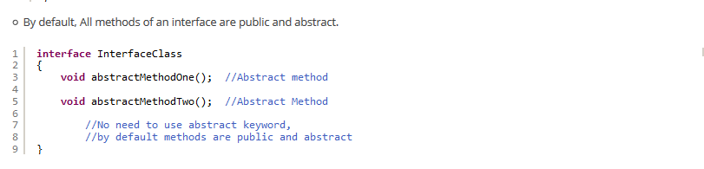

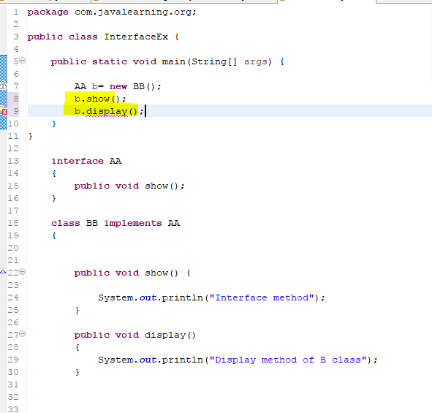

Q: If we can’t create an object of interface then what is use of interface?

Answer: The main purpose of interface is to provide the prototype/or templates which the other classes can implement it.

From another site





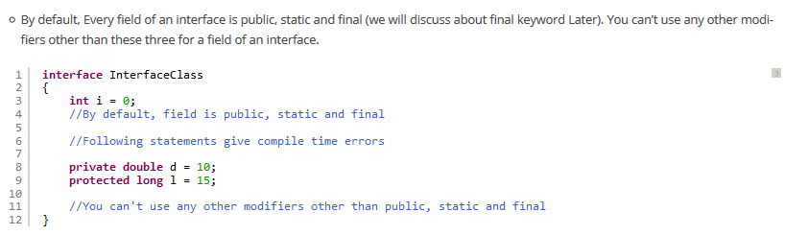



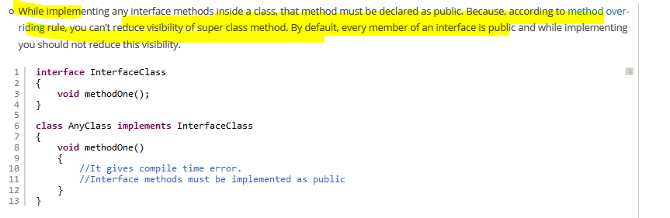

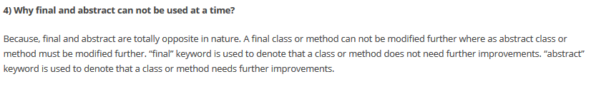

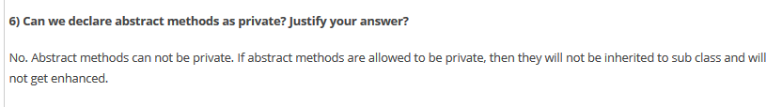

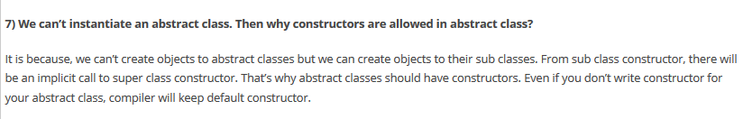

Like classes, for every interface .class file will be generated after compilation.

While implementing any interface methods inside a class, that method must be declared as public. Because, according to [method overriding](https://javaconceptoftheday.com/method-overriding-java/) rule, you can’t reduce visibility of super class method. By default, every member of an interface is public and while implementing you should not reduce this visibility.

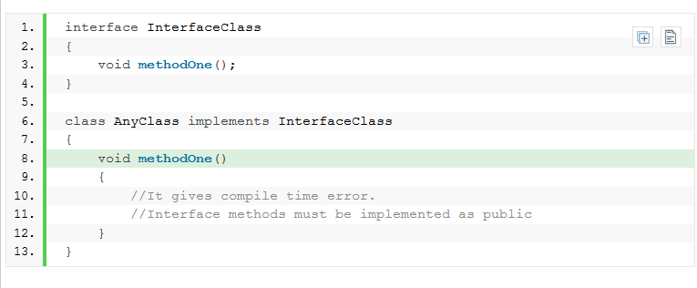

As we all know that, any class in java cannot extend more than one class. But class can implement more than one interfaces. This is how **multiple inheritance** is implemented in java.

